RESUME
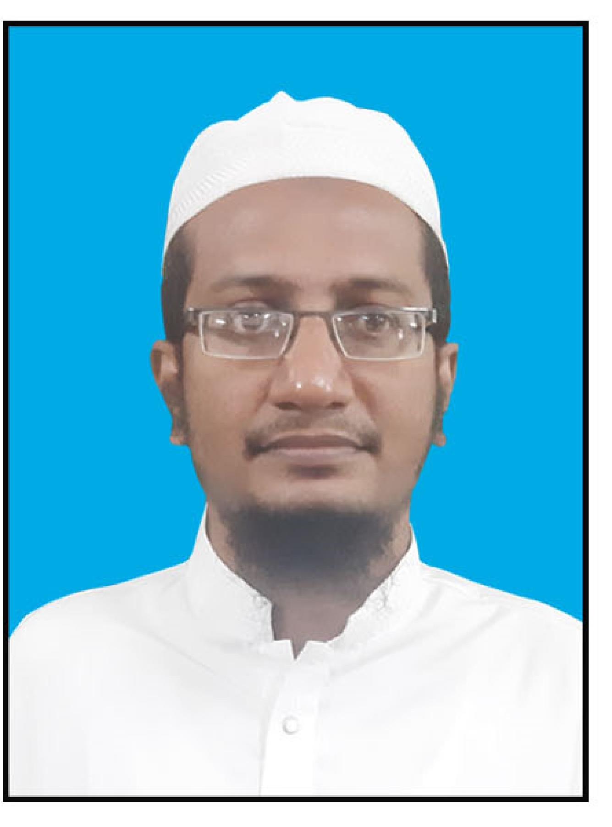
DR. S. MOHAMED MUDDASSIR
No. 5, New Market 3rd Street,
Melvisharam – 632 509,
Vellore Dist. Tamil Nadu
E-Mail. smmurdu@gmail.com
Mobile 90432 93097

OBJECTIVE :
To obtain a Fazilath in Hadees as lecturer in reputed educational institution where my acquired knowledge and skills can be utilized an optimum level.

Name of Madrasa | Board / University | Degree Certificates | Specification | Year of Passing
Darul Uloom Deoband | Darul Uloom Deoband | Fazil | Hadees | 2011
Madrasa-E-Manbaul Hasnath | Darul Uloom Sabeelurrashad | Aalim | Fiqua & Hadees | 2010
Madrasa-E-Manbaul Hasnath | Darul Uloom Sabeelurrashad | Qirath-E-Hafas | Quran | 2008
Madrasa-E-Manbaul Hasnath | Darul Uloom Sabeelurrashad | Qirath-E-Saba | Quran | 2008
Madrasa – E – Mazharul Huda, Melvisharam | Kashiful Huda, Chennai | Hifz | Quran | 2003

Name of Institute | Board / University | Degree Certificates | Specification | Year of Passing
Department of Arabic, Persian & Urdu | University of Madras | Ph.D., | Urdu | 2018
Department of Arabic, Persian & Urdu | University of Madras | M.Phil. | Urdu | 2013
University of Madras | University of Madras | M.A | Urdu | 2011
University of Madras | University of Madras | M.A | Arabic | 2018
C. Abdul Hakeem College, Melvisharam. | University of Madras | B.Sc., | Physics | 2005
Islamiah Higher Secondary School, Melvisharam | State Board | HSC | Science | 2000
Islamiah Higher Secondary School, Melvisharam | State Board | SSLC | General | 1998
NCPUL | NIELIT | CABA & MDTP | Computer | 2016
NCPUL | NCPUL | Diploma | Urdu | 2016
NCPUL | NCPUL | Certificate | Arabic | 2012
NCPUL | NCPUL | Diploma | Arabic | 2014
NCPUL | NCPUL | Certificate | Persian | 2019
University of Madras | University of Madras | Certificate | Tamil | 2019

Teaching Experiences :
- Working as Assistant Professor, Department of Urdu, Jamal Mohamed College [Autonomous], Trichy from 16th June 2015 to till.
- Worked as an Assistant Professor, Department of Urdu, C. Abdul Hakeem College [Autonomous], Melvisharam from 26th December, 2013 to 14th June 2015.
- Worked as a Teacher in Arabic College at Chennai from 2011 to 2013

Research Experience

DETAILS OF SEMINAR ORGANIZED

S.No. | Held at | Sponsored by | Date | Organized
1 | Jamal Mohamed College,  Trichy-620020 | NCPUL, New Delhi | 4th October, 2021 | Coordinator

INTERNATIONAL SEMINAR ATTENDED

S.No. | Held at | Sponsored by | Date | Presentations/ Participation
1 | C. Abdul Hakeem College, Melvisharam-632509 | NCPUL, New Delhi | 19th & 20th December 2016 | Presented a paper

NATIONAL SEMINARS ATTENDED

S.No. | Held at | Sponsored by | Date | Presentations/ Participation
1 | Justice Basheer Ahmed Sayeed College for Women, Chennai-18 | NCPUL, New Delhi | 26th &27th November 2013 | Presented a paper
2 | Mazharul Uloom College, Ambur-02 | UGC | 20th &21st January 2015 | Presented a paper
3 | Department of Arabic, Persian & Urdu | University of Madras, Chennai-5 | 27th January 2015 | Presented a paper
4 | C. Abdul Hakeem College, Melvisharam-632509 | UGC | 31st March 2015 | Presented a paper
5 | Department of Urdu | S.T.S.N Govt. Degree College, Kadri-515591 | 4th & 5th September 2015 | Presented a paper
6 | Department of Urdu | Justice Basheer Ahmed Sayeed College for Women, Chennai-18 | 16th September 2015 | Presented a paper
7 | Mazharul Uloom College, Ambur-02 | NCPUL, New Delhi | 5th & 6th October 2015 | Presented a paper
8 | Kuvempu University, Shivamogga | Karnataka Urdu Academy Bengaluru | 7th &8th January 2016 | Presented a paper
9 | Department of Urdu | Islamiah Women’s Arts & Science College, Vaniyambadi-52 | 18th February 2016 | Presented a paper
10 | University of Madras, Chennai | NCPUL, New Delhi | 9th & 10th November 2016 | Presented a paper
11 | Department of Urdu | Justice Basheer Ahmed Sayeed College for Women, Chennai-18 | 29th August 2017 | Presented a paper
12 | The New College, Chennai-14 | NCPUL, New Delhi | 13th & 14th September 2017 | Presented a paper
13 | Islamiah College, Vaniyambadi | NCPUL, New Delhi | 29th & 30th October 2017 | Presented a paper
14 | C. Abdul Hakeem College, Melvisharam-632509 | NCPUL & ICHR | 13th & 14th March 2019 | Presented a paper
15 | University of Madras, Chennai | NCPUL, New Delhi | 27th & 28th March 2019 | Presented a paper
16 | Sri Venkateswara University, Tirupati. | NCPUL, New Delhi | 19th & 20th February 2020 | Participated
17 | Islamiah College, Vaniyambadi | NCPUL, New Delhi | 1st March 2020 | Presented a paper
18 | University of Madras, Chennai | NCPUL, New Delhi | 1st & 2nd March 2021 | Presented a paper

WORKSHOPS ATTENDED:

S.No. | Held at | Sponsored by | Date | Presentations/ Participation
1 | Department of Urdu | Justice Basheer Ahmed Sayeed College for Women, Chennai-18 | 6th March 2014 | Participated
2 | Curriculum Development Cell | C. Abdul Hakeem College, Melvisharam-632509 | 26th February 2015 | Participated
3 | Internal Quality Assurance Cell | Jamal Mohamed College, Trichy-20 | 7th January 2017 | Participated
4 | Internal Quality Assurance Cell | Jamal Mohamed College, Trichy-20 | 23rd June 2018 | Participated
5 | Curriculum Development Cell | Jamal Mohamed College, Trichy-20 | 18th & 19th January 2017 | Participated

FACULTY DEVELOPMENT PROGRAMMES ATTENDED:

S.No | Title of the Program | Date | Presentations/ Participation
1 | The Role of a Teacher in the Present Scenario | 07-01-2017 | Participated
2 | Improving Teaching Practices- A Strategic Approach | 23-06-2018 | Participated
3 | Professional Development for Academic Leadership in Curriculum Design | 18-01-2019 to 19-01-2019 | Participated
4 | Staff Enrichment Programme | 14-06-2019 | Participated
5 | Swayam ARPIT Online Course (Urdu Refresher Course) | 30-06-2019 | Participated
6 | ICT Tools for Effective Teaching Learning | 11-05-2020 to 16-05-2020 | Participated
7 | Online Teaching via Google LMS During Covid-19 Pandemic | 28-05-2020 to 30-05-2020 | Participated
8 | The Role of Edutech in Classroom Teaching and Learning | 05-06-2020 to 11-06-2020 | Participated
9 | Online Course in Urdu Script Learning | 15-06-2020 to 30-08-2020 | Participated
10 | E-Content Development for Teaching and Learning | 21-06-2020 | Participated
11 | Faculty in Universities/Colleges/Institutes of Higher Education (Induction/Orientation) | 04-06-2020 to 01-07-2020 | Participated
12 | ICT Based Teaching and Learning Process | 01-07-2020 to 05-07-2020 | Participated
13 | Professional Development of Urdu Medium Teachers | 13-07-2020 to 18-07-2020 | Participated
14 | National Education Policy | 16-09-2020 to 17-09-2020 | Participated
15 | Short Term Course on Prosody Techniques (Arooz Daani) | 23-11-2020 to 29-11-2020 | Participated
16 | Online Course in Urdu Language Teaching | 16-11-2020 to 15-03-2021 | Participated
17 | Initiatives for Teaching – Learning Excellence in Urdu | 22-02-2021 to 27-02-2021 | Participated
18 | Subject Refresher Course in Oriental Studies (Arabic/ Islamic Studies/ Persian/ Theology/ Urdu) | 15-11-2021 to 29-11-2021 | Participated

Teaching Experience : 8 Years

Publications : 1. ADAB-E-JAMEEL, edited by S. Mohamed Muddassir
with ISBN 978-81-927802-6-9
2. Member, Urdu section, Al- Jamal, College Magazine.
3. Urdu Nasr ke ek aham nam-Deputy Nazeer Ahmed,
(A journal in Qaumi Zuban with ISSN 2321-4627)
4. Sir Syed Ahmed Khan Ilmi wa adabi khidmath -ek jaiza
(A chapter in Sir Syed Ahmed Khan Shakhsiyat Aur Khidmaat
With ISBN 978-93-5288-718-7)

DETAILS OF MEMBERSHIP IN ACADEMIC BODIES:

Chairman, Board of studies in Urdu, Jamal Mohamed College,
Member, Board of studies in Urdu, Madurai Kamaraj University, Madurai
Member, Board of studies in Urdu, C Abdul Hakeem College,

Member, Board of Examiners in Urdu, Bharathiar University, Coimbatore
Member, Board of Examiners in Urdu, Madurai Kamaraj University, Madurai
Member, Board of Examiners in Urdu, Bharathidasan University
Member, Board of Examiners in Urdu, Jamal Mohamed College,
Member, Board of Examiners in Urdu, C Abdul Hakeem College,

Question Paper setter, Bharathiar University, Coimbatore
Question Paper setter, Thiruvalluvar University, Vellore
Question Paper setter, Jamal Mohamed College, Tiruchrapalli-20
Question Paper setter, Jamal Mohamed College, Tiruchrapalli-20
Question Paper setter, C Abdul Hakeem College, Melvisharam
Question Paper setter, The New College, Chennai

Social Work
Executive member, Ansaar Educational & Welfare Society, Melvisharam bearing Reg. No.70/2011 under the TNSRA 1975

PERSONAL PROFILE:
Father’s Name : Janab S. Mohamed Noaman Sahib
Sex : Male
Nationality : Indian
Religion : Islam
Permanent Address : No. 5, New Market 3rd Street,
Melvisharam – 632 509,
Vellore Dist.
Tamil Nadu
India
Ph. 90432 93097
E-Mail Address : smmurdu@gmail.com

Language known :
Languages | Reading | Writing | Speaking
Urdu
English
Tamil
Arabic
Persian
Hindi

DECLARATION

I, S. Mohamed Muddassir, hereby declare that all statements made in this resume are true completed and correct to the best of my knowledge and belief.

(S. Mohamed Muddassir)
Date: 03rd January, 2023
Place: Melvisharam

